**EMAIL SPAM DETECTION USING LSTM**

**KATRAGADDA RAJESH 1, THIRUMALA SAI SUNDAR 2 ARETI RACHANA 3, MANDA HARITHA 4, MANEPALLI BHANU SRI 5**

***rajesh.k@nriit.edu.in 1,*** *Assistant Professor,* DEPT Of CSM, NRI Institute of Technology, AP-521212.

[***saisundar10@gmail.com***](mailto:saisundar10@gmail.com) ***2,*** *20KN1A4259,* DEPT Of CSM, NRI Institute of Technology, AP-521212.

***rachanaareti@gmail.com 3,*** *20KN1A4204,* DEPT Of CSM, NRI Institute of Technology, AP-521212.

[***harithamanda03@gmail.com***](mailto:harithamanda03@gmail.com) ***4,*** *20KN1A4234,* DEPT Of CSM, NRI Institute of Technology, AP-521212.

[***bhanusrimanepalli9@gmail.com***](mailto:bhanusrimanepalli9@gmail.com) ***5,*** *20KN1A4235,* DEPT Of CSM, NRI Institute of Technology, AP-521212.

-----------------------------------------------------------------***------------------------------------------------------------------

**ABSTRACT -** *The Long Short-Term Memory (LSTM) neural network constructed with Keras is smoothly integrated with Flask, a Python web framework, to create a web-based email spam classification system proposed in this project. The user-friendly interface of the system facilitates the efficient prediction of spam in text messages. Utilizing a dataset from a CSV file, the script uses tokenization and label encoding as preprocessing methods to get the data ready for LSTM model training. By successfully identifying spam from non-spam communications, the resultant model demonstrates the marriage of web development and deep learning*.*The special fusion of Flask and LSTM offers a workable and quick fix for the enduring problem of spam detection. Users may engage with the model with ease because to the Flask interface, which promptly predicts whether a given text message is spam. In summary, this abstract provides a flexible and user-friendly solution to the widespread problem of spam in digital communication by combining the collaborative synergy of modern machine learning techniques with established web building frameworks.*

**KEYWORDS:**

Web-based classification of spam , The framework Flask, Long Short-Term Memory (LSTM), Natural Language Processing (NLP), Classification of texts, Artificial intelligence, Neural networks with recurrent connections (RNNs), Design of LSTM architecture, Interface that is easy to use, Tokenization, Label encoding, Dataset preparation, Training models, Interaction with users, Digital communication, Sequence handling

1. **INTRODUCTION:**

In this project, a Long Short-Term Memory (LSTM) neural network constructed using Keras is smoothly integrated with Flask, a Python web framework, to create a web-based email spam classification system. A user-friendly interface allows the technology to streamline the intuitive and efficient prediction of email spam. The script uses preprocessing methods such as label encoding and tokenization to get ready the data for LSTM model training, using a dataset that was taken from a CSV file. The final model successfully distinguishes between emails that are spam and those that are not, demonstrating the fusion of web development and deep learning.

Email spam detection has always been a difficult problem, but the creative combination of Flask and LSTM offers a practical and quick fix. Users can engage with the model with ease thanks to the Flask interface, which provides users with instantaneous predictions about the probability that emails they give are spam. The collaborative synergy between conventional web development frameworks and state-of-the-art machine learning techniques is encapsulated in this abstract, which offers a flexible and user-friendly solution to the problem of spam common in digital communication.

1. **LITERATURE REVIEW:**

A Significant amount research in natural language processing (NLP) and machine learning, with a focus on text classification challenges, forms the foundation of the suggested web-based method for classifying emails as spam. Recurrent neural networks (RNNs), in particular Long Short-Term Memory (LSTM) networks, have been extensively studied for their ability to capture the sequential dependencies present in textual input. Since LSTM was first proposed in 1997 by Hochreiter and Schmidhuber, modeling of long-range dependencies in sequential data has been improved. This is because LSTM addresses the vanishing gradient issue that standard RNNs pose. Later studies—Griffith et al., 2005, for example—have demonstrated the usefulness of LSTMs in a variety of natural language processing (NLP) scenarios, including spam identification.

The synergy between web development and machine learning to enhance accessibility and user interaction has been studied recently. The combination of machine learning models with Flask, a lightweight Python web framework, is in line with the current trend of developing applications that are responsive and easy to use. This method has been covered by Ronacher (2010), who emphasizes Flask's adaptability and ease of use for building web apps. The current project's integration of Flask and LSTM broadens the scope of this research by showing how to practically implement an email spam classification system that prioritizes user experience while utilizing cutting-edge machine learning techniques.

1. **EXISTING SYSTEM:**

The Naive Bayes algorithm, a fundamental technique in text categorization, forms the basis of the current email spam detection system. Based on the Bayes theorem, the system uses a probabilistic model to calculate the likelihood that an email will be categorized as authentic or spam. The first step in the procedure is to train the Naive Bayes classifier with a labeled dataset of emails that have been classified as spam or not. The conditional probabilities of features, such as individual words or word pairs, given their corresponding class labels, are taught to the algorithm during training.Accurate classification is made possible by using this learned information to compute the probability that unseen emails fall into either group.

Naive Bayes's computational efficiency and simplicity are its strongest points. Its streamlined approach enables real-time email categorization and rapid model training, even with the assumption of feature independence. Because of the algorithm's ability to handle massive datasets and high-dimensional data, the current email spam detection system can effectively use it. Even though Naive Bayes may not take into account complex feature dependencies, it is nevertheless a dependable and effective part of modern email security systems, offering quick and precise email classification as spam or non-spam.

1. **PROPOSED SYSTEM**

The solution that is being suggested is a well-thought-out web-based interface that is designed to effectively identify and categorize email communications as either spam or acceptable material. The system is based on the Long Short-Term Memory (LSTM) neural network, which is a well-known architecture that is highly regarded for its ability to understand sequences in spoken language. This neural network is trained with a carefully selected dataset that is taken from a CSV file, and it is integrated into the Keras framework without any issues. This group of examples includes labeled emails that are not spam. The system leverages the Flask web framework to improve user engagement. It provides an easy-to-use interface that allows users to enter emails and get predictions in real time on how likely they are to be spam.

The proposed system presents an adaptable and user-centric paradigm that goes beyond traditional spam filters. Users with different levels of technical expertise can interact with the complex LSTM model with ease thanks to the Flask interface, which democratizes access. The architecture of the system embraces scalability and versatility, making it ready for future improvements and integrations. The system is at the forefront of cutting-edge approaches for email classification since it makes use of LSTM, a reliable sequence modeling methodology. Iterative refinement of the system could allow it to dynamically adapt to changing spam patterns, providing a dependable and effective solution for people looking for a sophisticated yet approachable tool for email spam detection in the constantly changing world of digital communication channels.

1. **METHODLOGIES USED:**
2. **Data Loading and Pre-processing:** Using the pandas package, load the dataset is the initial step. The collection, which is kept in a CSV file, includes details on communications that are classified as "spam" or "ham." In the pre-processing stage, the dataset is arranged to make subsequent model training easier, a new label column is made, and categorical data is encoded using label encoding.
3. **Train Test Split:** The code splits the dataset into trains and tests using scikit-learn. By dividing the data into training and testing sets, this methodology allots 80% of the data for training the model and reserves the remaining 20% for assessing the model's performance.
4. **Tokenization and Sequence Padding:** By tokenizing the text data and turning messages into a series of numbers, the Keras Tokenizer is utilized. Transforming textual data into a format that neural networks can use is a critical stage in this process. Moreover, sequence padding guarantees uniform length for every input sequence, which makes batch processing during model training more effective.
5. **Neural Network Architecture:** Creating a neural network architecture with the Keras library is the key process of the methodology. Activation functions are used to introduce non-linearity, thick layers are used to account for model complexity, and LSTM layers are used to process sequential data. The model is appropriate for binary classification tasks and is constructed using the binary crossentropy loss function and RMSprop optimizer.
6. **Model Training:** Tokenized and pre processed data is used to train the neural network model. The model's parameters are changed during training in order to minimize the loss of binary cross entropy on the training set. During training, the EarlyStopping callback is used to track the validation loss and stop the process when the improvements stop, so avoiding overfitting.
7. **Flask Web Application:** Flask provides the framework for handling user interactions, HTML template rendering, and routing in the implementation of the web application. There are two routes in the application: one that renders the index page and processes user input, while the other uses the trained model to anticipate future events.
8. **User Input Processing and Prediction:** User input is processed using tokenization and sequence padding to match the input requirements of the model. The user input takes the form of a message. Subsequently, the trained model makes a prediction on the spam-ness of the input message. Indicating whether or not the communication is categorized as spam, the outcome is shown on the webpage.
9. **TECHNOLOGIES USED:**
10. **Pandas:** The pandas package, a potent Python tool for data manipulation and analysis, is used in the code. In this case, the dataset is loaded and preprocessed using pandas. This includes encoding categorical data, generating a new label column, and structuring the data in order to train the machine learning model.
11. **Scikit-Learn:** Model training and assessment activities make use of the Python machine learning package scikit-learn. In order to prepare the data for training the neural network model, it is specifically used to split the dataset into training and testing sets and to execute label encoding.
12. **Keras:** The spam detection model was developed and trained mostly using Keras, an open-source Python neural network API. Activation functions, dense layers, and LSTM layers are all included in the code that forms a neural network architecture using Keras. Additionally,
13. **RMS Prop:** For the purpose of compiling the neural network model, the optimization technique RMSprop is utilized. As a result, it contributes to the model's overall optimization during training by effectively changing the learning rates for various model parameters.
14. **LSTM:** Recurrent neural network layers of the Long Short-Term Memory (LSTM) variety are used in neural network architectures. Since LSTMs can handle sequence data well, they are useful for problems involving natural language processing, like this one involving spam detection.
15. **Early Stopping:** When the model is being trained, the code makes use of Keras' EarlyStopping callback. When a tracked quantity, in this example the validation loss, stops getting better, EarlyStopping enables the training process to discontinue. By doing so, overfitting is less likely to occur and training efficiency is increased.
16. **SYSTEM DESIGN:**

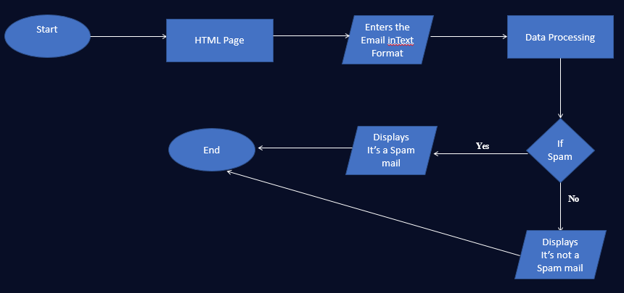

**Fig-1 System Design**

1. **FUTURE SCOPE:**

Further development of the spam detection model is where the offered code will be most useful. This is investigating cutting edge methods in machine learning and natural language processing (NLP) to enhance the predictive power of the model. Intricate patterns and semantic subtleties in text data may be captured by the system by experimentation with sophisticated neural network topologies, such as transformer-based models like BERT or GPT. Accurate and reliable spam detection will be enhanced by ongoing optimization through hyper parameter adjustments and fine-tuning on a variety of datasets.

Future directions worth exploring include extending the application's functionality to support several languages and customizing it for various cultural contexts. Training the model on datasets reflecting linguistic variances is necessary to incorporate multilingual support. It will also make the model more flexible to take into account cultural variations in spam patterns and communication approaches. Due to the global diversity of languages and communication conventions, this comprehensive approach guarantees that the spam detection system becomes more inclusive and successful.

Opportunities for the code's integration with new trends arise from the advancement of technology. Scalability and accessibility can be improved by cloud deployment on systems like AWS, Google Cloud, or Azure. Additionally, investigating partnerships with email service providers to smoothly incorporate the spam detection technology into current email platforms can have a big effect on user experience. Furthermore, thinking about how the program may be integrated into mobile platforms—for example, by creating a mobile application—would increase the system's reach and give consumers easy-to-use spam detection capabilities while they're on the road. Retaining user confidence in the rapidly changing digital communication ecosystem will require adopting privacy-focused technologies and upholding strict security protocols.

1. **CONCLUSION:**

In Conclusion, the application of Long Short-Term Memory (LSTM) networks for email spam detection is a noteworthy advancement towards the more precise and sophisticated detection of harmful information through digital messages. It has shown encouraging results to separate spam from real messages by using LSTM architecture, which has the innate capacity to capture sequential dependencies and contextual nuances in text data. It is possible to predict spam in real time with ease thanks to the combination of web development with machine learning, as demonstrated by the Flask application.

Looking ahead, there is a ton of room for improvement and growth in the field of LSTM-based email spam detection. Important directions for advancement include investigating sophisticated architectures, adjusting to changing spam strategies, and continuously fine-tuning the model to optimize efficiency. Key directions for research and development that stand out are explainability, user-centric customisation, and real-time flexibility and dynamic updating. The constant struggle against the ever-changing issues provided by email spam will depend heavily on the proactive integration of state-of-the-art methods and user-centric features as the digital world continues to change.

1. **RESULT:**

A Long Short-Term Memory (LSTM) neural network is used by the system to process natural language sequences effectively. Using Keras Tokenizer, the training email text data is tokenized, then layers for activation, sequence processing, and embedding are added to the LSTM model. The accuracy metric, RMSprop optimizer, and binary cross-entropy loss are used in the compilation of the model. Routes for the main page and prediction endpoint are set up for the Flask web application. Users can insert email messages into the HTML template's user-friendly interface to get real-time estimates about how likely they are to be spam.

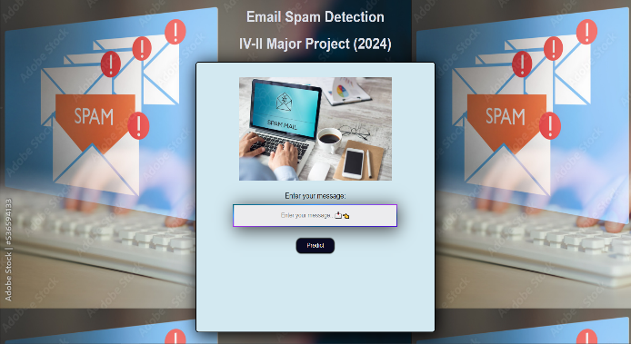

**Fig:2 Home page**

Users can enter their email messages in the box of the web application.

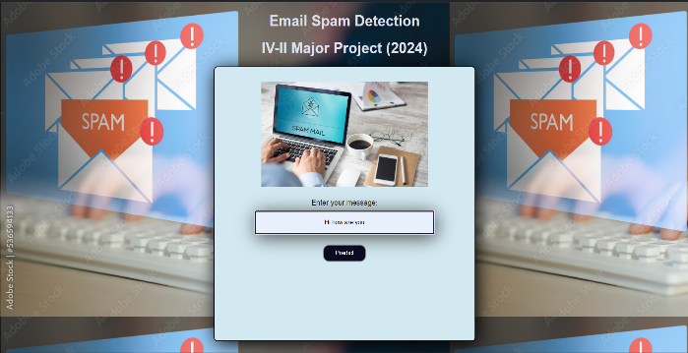

**Fig:3 Entering the text**

After submission, the model uses the trained LSTM network to process the input, and the webpage dynamically displays the prediction.

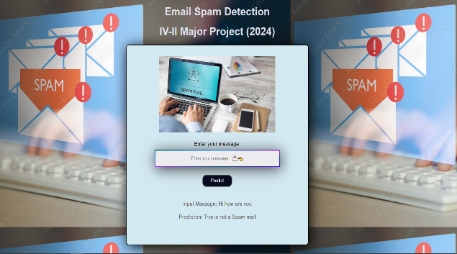

**Fig-3: Predicted Result**

The Flask web application incorporates the predictions of the model, enabling users to interact with it without requiring extensive technical knowledge. The result is a user-centric web environment where machine learning—more precisely, LSTM—is applied practically for email spam detection.

1. **REFERENCES:**
2. Thashina Sultana, K A Sapnaz, Fathima Sana, Mrs. Jamedar Najath, Dept. of Computer Science and Engineering

Yenepoya Institute of Technology

Moodbidri, India.

1. O. Saad, A. Darwish and R. Faraj, "A survey of machine learning techniques for Spam filtering", Int. J. Comput. Sci. Netw. Secur., vol. 12, pp. 66, Feb. 2012.
2. M. K. Paswan, P. S. Bala and G. Aghila, "Spam filtering: Comparative analysis of filtering techniques", Proc. Int. Conf. Adv. Eng. Sci. Manage. (ICAESM), pp. 170-176, Mar. 2012.
3. R. Islam and Y. Xiang, "Email classification using data reduction method", Proc. 5th Int. ICST Conf. Commun. Netw. China, pp. 1-5, Aug. 2010
4. N. Banu and M. Banu, "A Comprehensive Study of Phishing Attacks", Int. J. Comput. Sci. Inf. Technol., vol. 4, no. 6, pp. 783-786, 2013.
5. **BIOGRAPHIES:**